**PREDICTION OF CREDIT CARD SEGMENTATION**

**ARJUN PRAKASH**

**18-11-2019**

1. INTRODUCTION 3-4

* 1. Problem Statement
  2. Data Set

1. METHODOLOGY 5-7
   1. Preprocessing
      1. Detection Of Outliers
      2. Identify the outlier in dataset from IQR method
2. Deriving KPI's 8-9
   1. Monthly average purchase and Cash Advance Amount
   2. Purchased by Type (one-off, installments)
   3. Limit usage (balance to credit limit ratio)
   4. Payments to minimum payments ratio in percentage

# Insights on new KPI 9-11

# Data Standardizing 12

# Principal Components Analysis 13

# MODELING 13-15

* 1. Model Building
     1. K Means Clustering
     2. 5 Cluster
     3. 6 Clusters
     4. 7 Clusters
  2. Checking Performance for k means

1. CONCLUSION 16

8.1 Conclusion

1. APPENDIX A 17-33

Python Code

R CODE

1. **Introduction**
   1. Problem Statement

This case requires trainees to develop a customer segmentation to define

Marketing strategy. The sample dataset summarizes the usage behavior of about 9000

active credit card holders during the last 6 months. The file is at a customer level with

18 behavioral variables.

* 1. Data Set

The goal is to build the models which will predict a customer segmentation to define

Marketing strategy. Below is the sample of the data set that we are using to predict the Credit Card Segmentation:

Table 1.1: Credit Card Segmentation Sample Data (Columns: 1-8)

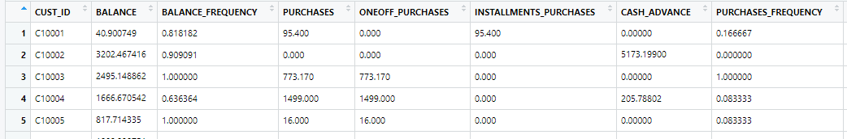

Table 1.2: Credit Card Segmentation Sample Data (Columns: 9-15)

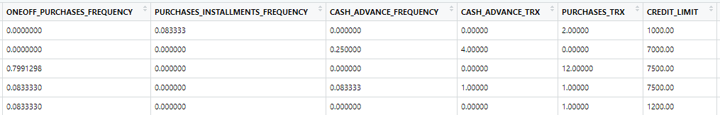

Table 1.3: Credit Card Segmentation Sample Data (Columns: 16-19)

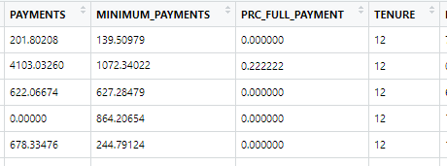

In the below Table we have the following 13 variables, using which we have to predict the Credit Card Segmentation:

|  |  |
| --- | --- |
| **Sl.No** | **Variables** |
| 1 | CUST_ID |
| 2 | BALANCE |
| 3 | BALANCE_FREQUENCY |
| 4 | PURCHASES |
| 5 | ONEOFF_PURCHASES |
| 6 | INSTALLMENTS_PURCHASES |
| 7 | CASH_ADVANCE |
| 8 | PURCHASES_ FREQUENCY |
| 9 | ONEOFF_PURCHASES_FREQUENCY |
| 10 | PURCHASES_INSTALLMENTS_FREQUENCY |
| 11 | CASH_ADVANCE_ FREQUENCY |
| 12 | AVERAGE_PURCHASE_TRX |
| 13 | CASH_ADVANCE_TRX |
| 14 | PURCHASES_TRX |
| 15 | CREDIT_LIMIT |
| 16 | PAYMENTS |
| 17 | MINIMUM_PAYMENTS |
| 18 | PRC_FULL_PAYMENT |
| 19 | TENURE |

Table 1.3: Credit Card Segmentation

1. **Methodology**
   1. Pre-Processing

2.2.1 Detection of Outliers

Outliers:An outlier is a data point in a data set that is distant from all other observations. A data point that lies outside the overall distribution of the datasetOutliers are detected using boxplots. Below figure illustrates the boxplots.

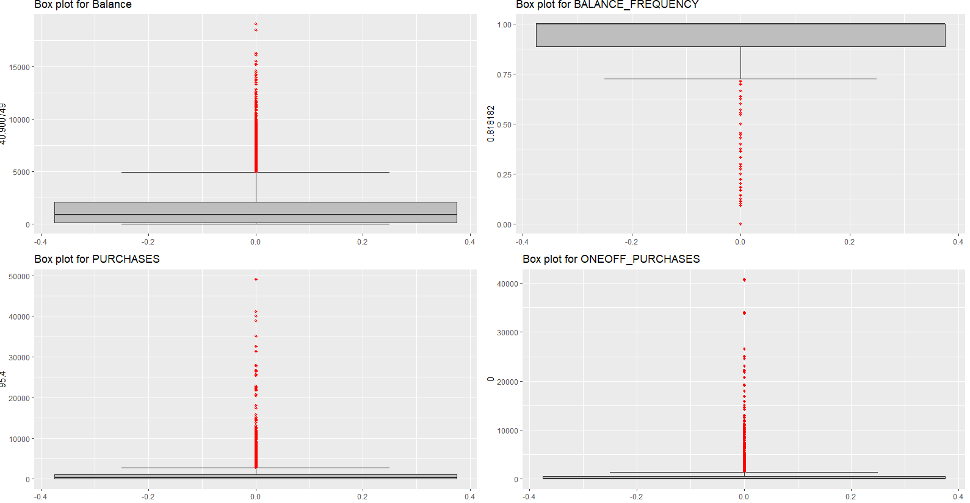

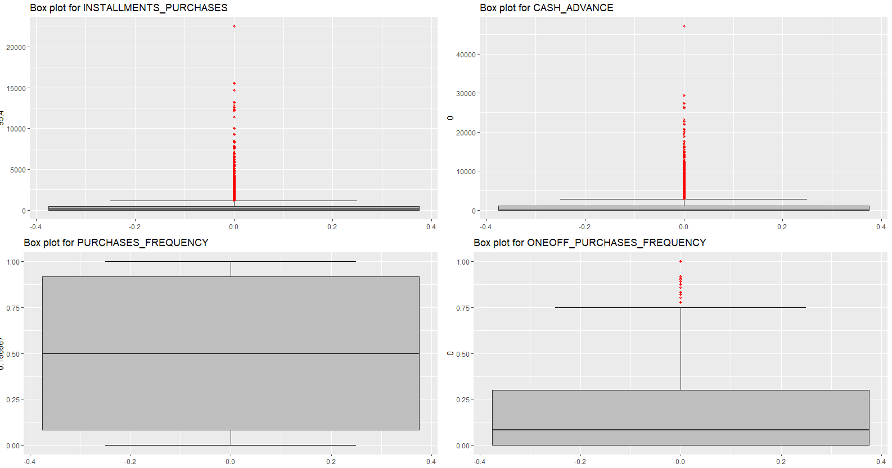

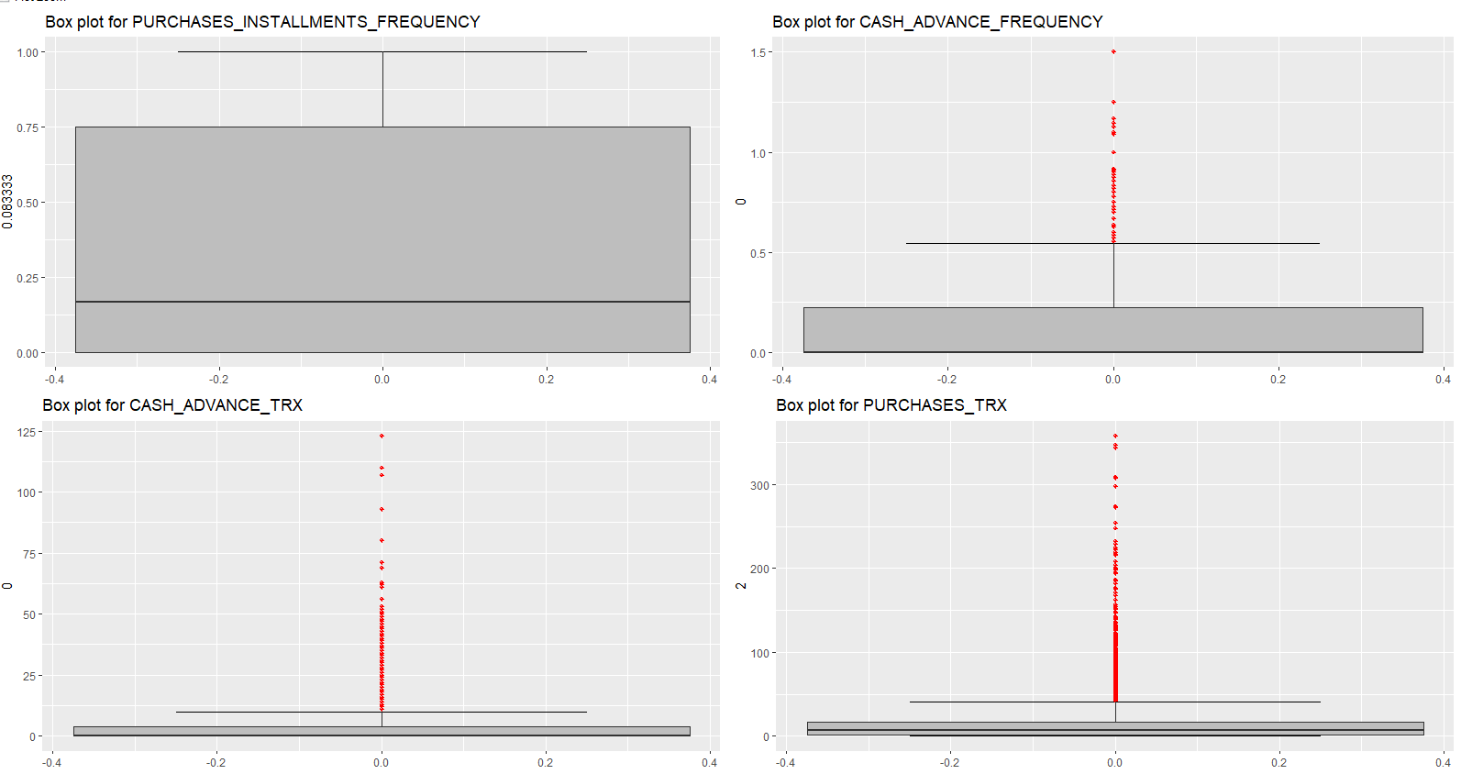

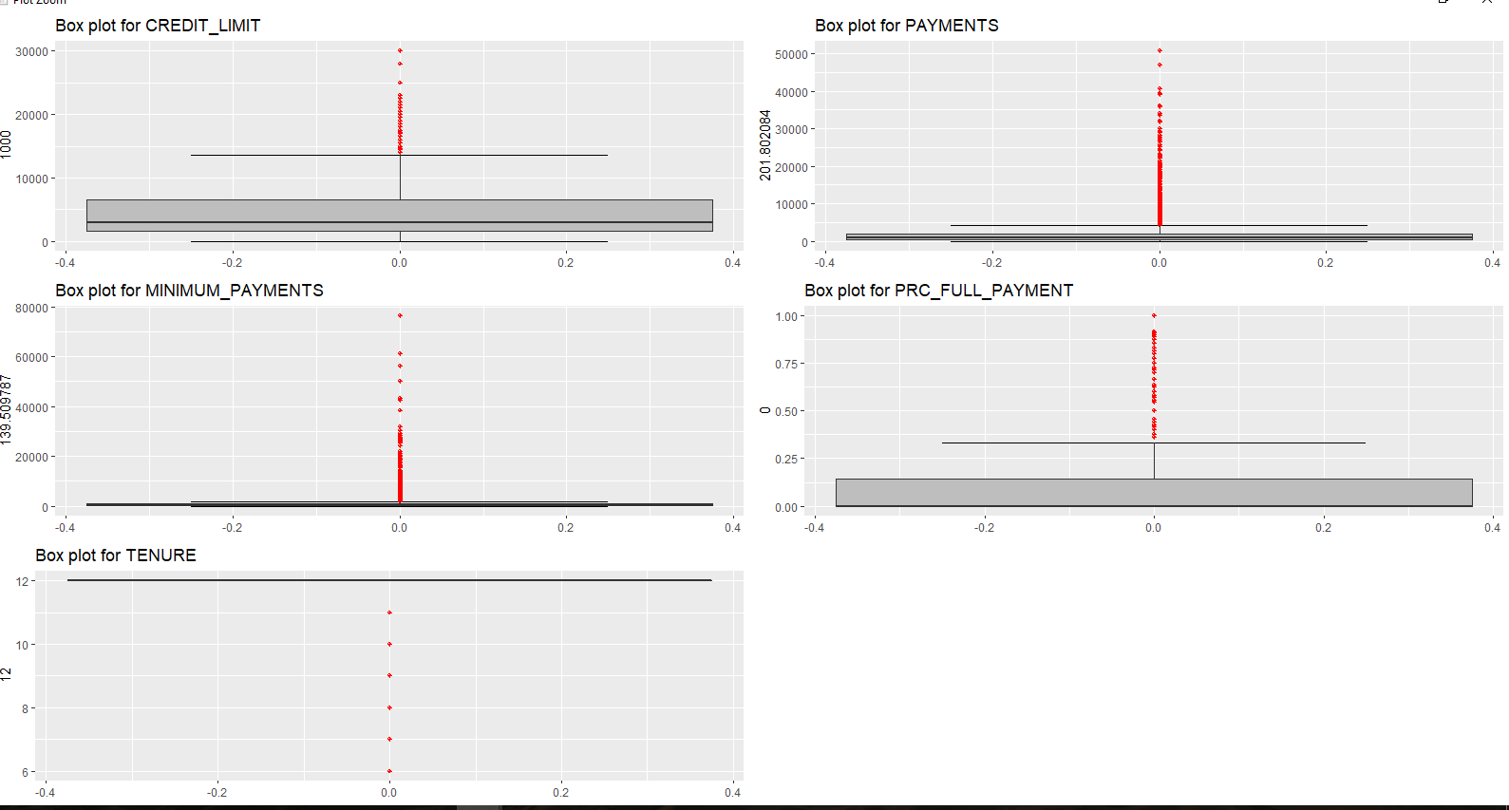

2.2.2 Identify the outlier in dataset from IQR method

Outliers can be identified using the IQR method, wherein the Inter Quartile Range (IQR) is calculated and the minimum and maximum values are calculated for the variables. Any value ranging outside the minimum and maximum value are discarded.

**3 Deriving KPI's**

Key Performance Indicators

A Key Performance Indicator (KPI) is a measurable value that demonstrates how effectively a company is achieving key business objectives. Organizations use KPIs to evaluate their success at reaching targets.

* 1. Monthly average purchase and Cash Advance Amount

Monthly Average Purchase

0 7.950000

1 0.000000

2 64.430833

3 124.916667

Cash Advance Amount

0 0.000000

1 536.91212

2 0.000000

3 17.149001

4 0.000000

3.2 Purchased by Type (one-off, installments)

4 types of purchase behavior has been seen

1. People not done both type of purchases (one-off, installments)

2. People done both type of purchases (one-off, installments)

3. People done only one-off payment type of purchases

4. People done only installments payment type of purchases

* 1. Limit usage (balance to credit limit ratio)

Limit usage

0 0.040901

1 0.457495

2 0.332687

3 0.222223

4 0.681429

* 1. Payments to Minimum Payments ratio in Percentage

Minimum Payments ratio

0 1.446508

1 3.826241

2 0.991682

3 0.000000

4 2.771075

**4 Insights on new KPI**

Plot graph on Purchase types

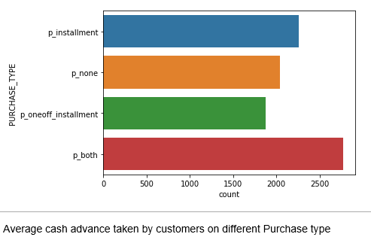

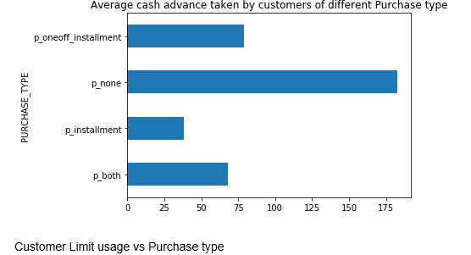

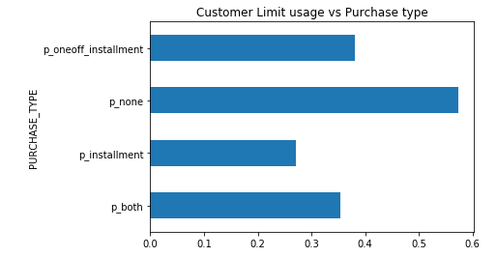

Heat Map – Show correlation between variable

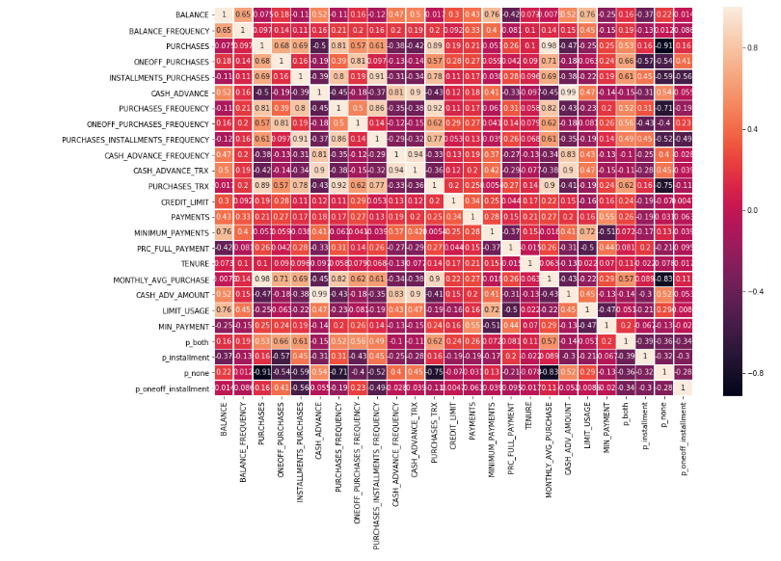

**5 Data Standardizing**

Feature scaling is a method used to normalize the range of independent variables or features of data. In data processing, it is also known as data normalization

**6 Performance Component Analysis (PCA)**

Principal component analysis (PCA) is a technique that is useful for the compression and classification of data. The purpose is to reduce the dimensionality of a data set (sample) by finding a new set of variables, smaller than the original set of variables, that nonetheless retains most of the sample's information

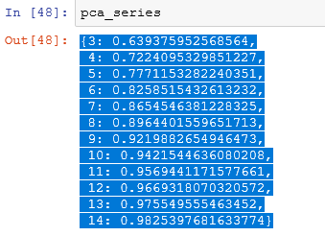

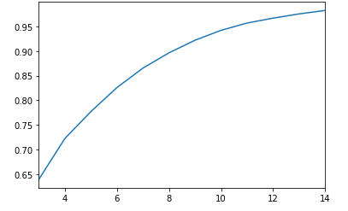

**7 Model Building**

7.1.1 K Means Clustering

K-means clustering is one of the simplest and popular unsupervised machine learning algorithms. ... In other words, the K-means algorithm identifies k number of centroids, and then allocates every data point to the nearest cluster, while keeping the centroids as small as possible

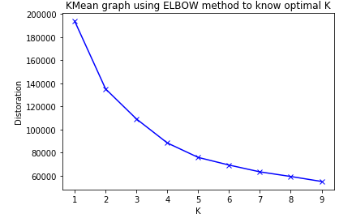

From the Elbow method we can take optimal K value as 5 since there are no drastic changes after 5.So we consider 5 Cluster initially and start building the model.

**7.1.2 5 Cluster**

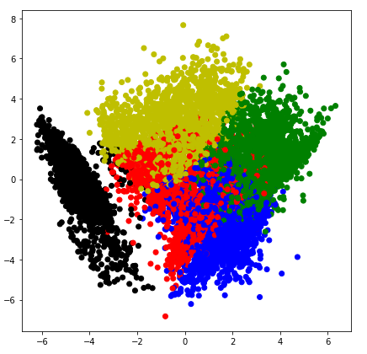

The Cluster in Black seems to be well segregated compred to other clusters.

**7.1.2 6 Cluster**

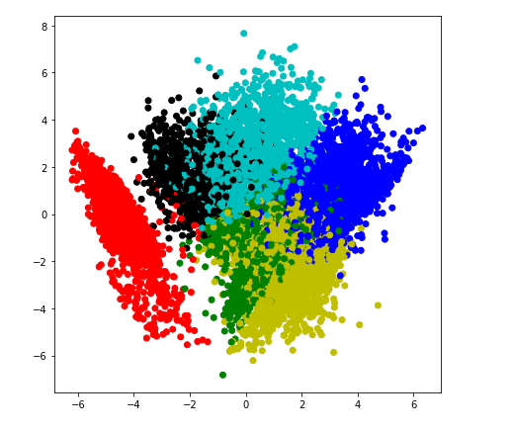

The cluster in red seems to be more segregated from other clusters.

**7.1.4 7 Cluster**

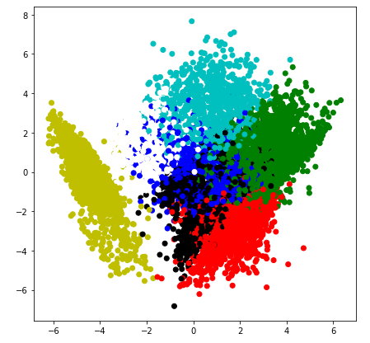

The cluster in yellow is more segregated than the others.

**7.2 Checking performance metrics for Kmeans**

We have used the calinski harabaz , silhouette methods used to validate the performance of K means Clusters and below are the scores

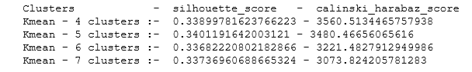

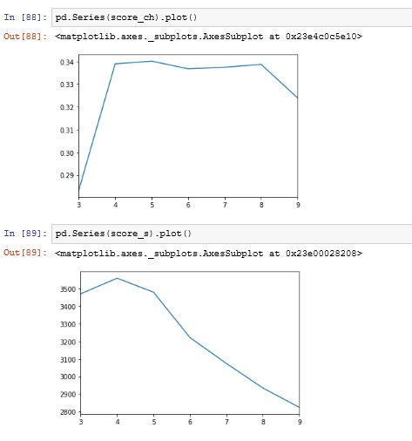

8 CONCLUSION

Marketing Strategy Suggested:

1. Group with both type of purchases

* They are potential target customers who are paying dues and doing purchases and maintaining comparatively good credit score ) -- we can increase credit limit or can lower down interest rate -- Can be given premium card /loyality cards to increase transactions

2 Group not done both type of purchases

* They have poor credit score and taking only cash on advance. We can target them by providing less interest rate on purchase transaction

1. Group done both type of purchases

* This group is has minimum paying ratio and using card for just oneoff transactions (may be for utility bills only). This group seems to be risky group.

4. Group done only installments payment type of purchases

* This group is performing best among all as cutomers are maintaining good credit score and paying dues on time. -- Giving rewards point will make them perform more purchases.

**9 Appendix A**

**PYTHON CODE:-**



**R CODE:-**

#Clear the environment

rm(list = ls())

rm(library)

#Load the Libraries

library(DataCombine)

library(ggplot2)

library(gridExtra)

library(dplyr)

library(magrittr)

library(corrplot)

library(corrgram)

library(psych)

library(GPArotation)

library(paran)

library(NbClust)

#Set Working directory

setwd("C:/Users/rnp/Desktop/Arjun/Data Science/Project3")

#Load the Credit card dataset

credit_df<- read.csv('credit-card-data.csv',header = T)

head(credit_df)

summary(credit_df)

View(credit_df)

dim(credit_df)

#Distribution of data attributes

hist_plot1 = ggplot(credit_df, aes(BALANCE))+theme_bw()+geom_histogram(fill='blue', bins = 20)+ggtitle("Distribution of Balance")+theme(text = element_text(size = 10))

hist_plot2 = ggplot(credit_df, aes(BALANCE_FREQUENCY))+theme_bw()+geom_histogram(fill='blue', bins = 20)+ggtitle("Distribution of BALANCE_FREQUENCY")+theme(text = element_text(size = 10))

hist_plot3 = ggplot(credit_df, aes(PURCHASES))+theme_bw()+geom_histogram(fill='blue', bins = 20)+ggtitle("Distribution of PURCHASES")+theme(text = element_text(size = 10))

hist_plot4 = ggplot(credit_df, aes(ONEOFF_PURCHASES))+theme_bw()+geom_histogram(fill='blue', bins = 20)+ggtitle("Distribution of ONEOFF_PURCHASES")+theme(text = element_text(size = 10))

hist_plot5 = ggplot(credit_df, aes(INSTALLMENTS_PURCHASES))+theme_bw()+geom_histogram(fill='blue', bins = 20)+ggtitle("Distribution of INSTALLMENTS_PURCHASES")+theme(text = element_text(size = 10))

hist_plot6 = ggplot(credit_df, aes(CASH_ADVANCE))+theme_bw()+geom_histogram(fill='blue', bins = 20)+ggtitle("Distribution of CASH_ADVANCE")+theme(text = element_text(size = 10))

hist_plot7 = ggplot(credit_df, aes(PURCHASES_FREQUENCY))+theme_bw()+geom_histogram(fill='blue', bins = 20)+ggtitle("Distribution of PURCHASES_FREQUENCY")+theme(text = element_text(size = 10))

hist_plot8 = ggplot(credit_df, aes(ONEOFF_PURCHASES_FREQUENCY))+theme_bw()+geom_histogram(fill='blue', bins = 20)+ggtitle("Distribution of ONEOFF_PURCHASES_FREQUENCY")+theme(text = element_text(size = 10))

hist_plot9 = ggplot(credit_df, aes(PURCHASES_INSTALLMENTS_FREQUENCY))+theme_bw()+geom_histogram(fill='blue', bins = 20)+ggtitle("Distribution of PURCHASES_INSTALLMENTS_FREQUENCY")+theme(text = element_text(size = 10))

hist_plot10 = ggplot(credit_df, aes(CASH_ADVANCE_FREQUENCY))+theme_bw()+geom_histogram(fill='blue', bins = 20)+ggtitle("Distribution of CASH_ADVANCE_FREQUENCY")+theme(text = element_text(size = 10))

hist_plot11 = ggplot(credit_df, aes(CASH_ADVANCE_TRX))+theme_bw()+geom_histogram(fill='blue', bins = 20)+ggtitle("Distribution of CASH_ADVANCE_TRX")+theme(text = element_text(size = 10))

hist_plot12 = ggplot(credit_df, aes(PURCHASES_TRX))+theme_bw()+geom_histogram(fill='blue', bins = 20)+ggtitle("Distribution of PURCHASES_TRX")+theme(text = element_text(size = 10))

hist_plot13 = ggplot(credit_df, aes(CREDIT_LIMIT))+theme_bw()+geom_histogram(fill='blue', bins = 20)+ggtitle("Distribution of CREDIT_LIMIT")+theme(text = element_text(size = 10))

hist_plot14 = ggplot(credit_df, aes(MINIMUM_PAYMENTS))+theme_bw()+geom_histogram(fill='blue', bins = 20)+ggtitle("Distribution of MINIMUM_PAYMENTS")+theme(text = element_text(size = 10))

hist_plot15 = ggplot(credit_df, aes(PRC_FULL_PAYMENT))+theme_bw()+geom_histogram(fill='blue', bins = 20)+ggtitle("Distribution of PRC_FULL_PAYMENT")+theme(text = element_text(size = 10))

hist_plot16 = ggplot(credit_df, aes(TENURE))+theme_bw()+geom_histogram(fill='blue', bins = 20)+ggtitle("Distribution of TENURE")+theme(text = element_text(size = 10))

gridExtra::grid.arrange(hist_plot1,hist_plot2,hist_plot3,hist_plot4,hist_plot5,hist_plot6,hist_plot7,hist_plot8,hist_plot9,

hist_plot10,hist_plot11,hist_plot12,hist_plot13,hist_plot14,hist_plot15,hist_plot16,nrow=4,ncol=4)

# Find Missing values

missing_value<-data.frame(missing_value=apply(credit_df,2,function(x){sum(is.na(x))}))

missing_value

#impute missing values with mean

credit_df$CREDIT_LIMIT[is.na(credit_df$CREDIT_LIMIT)] <- mean(credit_df$CREDIT_LIMIT, na.rm = TRUE)

credit_df$MINIMUM_PAYMENTS[is.na(credit_df$MINIMUM_PAYMENTS)] <- mean(credit_df$MINIMUM_PAYMENTS, na.rm = TRUE)

# Check for Missing values after imputation

missing_value<-data.frame(missing_value=apply(credit_df,2,function(x){sum(is.na(x))}))

missing_value

#******** Outlier detection ********#

box_plot1 = ggplot(aes_string(y = credit_df$BALANCE), data = credit_df)+stat_boxplot(geom = "errorbar", width = 0.5) +

geom_boxplot(outlier.colour="red", fill = "grey" ,outlier.shape=10,outlier.size=1, notch=FALSE) + theme(legend.position="bottom")+labs(y=credit_df$BALANCE)+ggtitle(paste("Box plot for Balance"))

box_plot2 = ggplot(aes_string(y = credit_df$BALANCE_FREQUENCY), data = credit_df)+stat_boxplot(geom = "errorbar", width = 0.5) +

geom_boxplot(outlier.colour="red", fill = "grey" ,outlier.shape=10,outlier.size=1, notch=FALSE) + theme(legend.position="bottom")+labs(y=credit_df$BALANCE_FREQUENCY)+ggtitle(paste("Box plot for BALANCE_FREQUENCY"))

box_plot3 = ggplot(aes_string(y = credit_df$PURCHASES), data = credit_df)+stat_boxplot(geom = "errorbar", width = 0.5) +

geom_boxplot(outlier.colour="red", fill = "grey" ,outlier.shape=10,outlier.size=1, notch=FALSE) + theme(legend.position="bottom")+labs(y=credit_df$PURCHASES)+ggtitle(paste("Box plot for PURCHASES"))

box_plot4 = ggplot(aes_string(y = credit_df$ONEOFF_PURCHASES), data = credit_df)+stat_boxplot(geom = "errorbar", width = 0.5) +

geom_boxplot(outlier.colour="red", fill = "grey" ,outlier.shape=10,outlier.size=1, notch=FALSE) + theme(legend.position="bottom")+labs(y=credit_df$ONEOFF_PURCHASES)+ggtitle(paste("Box plot for ONEOFF_PURCHASES"))

box_plot5 = ggplot(aes_string(y = credit_df$INSTALLMENTS_PURCHASES), data = credit_df)+stat_boxplot(geom = "errorbar", width = 0.5) +

geom_boxplot(outlier.colour="red", fill = "grey" ,outlier.shape=10,outlier.size=1, notch=FALSE) + theme(legend.position="bottom")+labs(y=credit_df$INSTALLMENTS_PURCHASES)+ggtitle(paste("Box plot for INSTALLMENTS_PURCHASES"))

box_plot6 = ggplot(aes_string(y = credit_df$CASH_ADVANCE), data = credit_df)+stat_boxplot(geom = "errorbar", width = 0.5) +

geom_boxplot(outlier.colour="red", fill = "grey" ,outlier.shape=10,outlier.size=1, notch=FALSE) + theme(legend.position="bottom")+labs(y=credit_df$CASH_ADVANCE)+ggtitle(paste("Box plot for CASH_ADVANCE"))

box_plot7 = ggplot(aes_string(y = credit_df$PURCHASES_FREQUENCY), data = credit_df)+stat_boxplot(geom = "errorbar", width = 0.5) +

geom_boxplot(outlier.colour="red", fill = "grey" ,outlier.shape=10,outlier.size=1, notch=FALSE) + theme(legend.position="bottom")+labs(y=credit_df$PURCHASES_FREQUENCY)+ggtitle(paste("Box plot for PURCHASES_FREQUENCY"))

box_plot8 = ggplot(aes_string(y = credit_df$ONEOFF_PURCHASES_FREQUENCY), data = credit_df)+stat_boxplot(geom = "errorbar", width = 0.5) +

geom_boxplot(outlier.colour="red", fill = "grey" ,outlier.shape=10,outlier.size=1, notch=FALSE) + theme(legend.position="bottom")+labs(y=credit_df$ONEOFF_PURCHASES_FREQUENCY)+ggtitle(paste("Box plot for ONEOFF_PURCHASES_FREQUENCY"))

box_plot9 = ggplot(aes_string(y = credit_df$PURCHASES_INSTALLMENTS_FREQUENCY), data = credit_df)+stat_boxplot(geom = "errorbar", width = 0.5) +

geom_boxplot(outlier.colour="red", fill = "grey" ,outlier.shape=10,outlier.size=1, notch=FALSE) + theme(legend.position="bottom")+labs(y=credit_df$PURCHASES_INSTALLMENTS_FREQUENCY)+ggtitle(paste("Box plot for PURCHASES_INSTALLMENTS_FREQUENCY"))

box_plot10 = ggplot(aes_string(y = credit_df$CASH_ADVANCE_FREQUENCY), data = credit_df)+stat_boxplot(geom = "errorbar", width = 0.5) +

geom_boxplot(outlier.colour="red", fill = "grey" ,outlier.shape=10,outlier.size=1, notch=FALSE) + theme(legend.position="bottom")+labs(y=credit_df$CASH_ADVANCE_FREQUENCY)+ggtitle(paste("Box plot for CASH_ADVANCE_FREQUENCY"))

box_plot11 = ggplot(aes_string(y = credit_df$CASH_ADVANCE_TRX), data = credit_df)+stat_boxplot(geom = "errorbar", width = 0.5) +

geom_boxplot(outlier.colour="red", fill = "grey" ,outlier.shape=10,outlier.size=1, notch=FALSE) + theme(legend.position="bottom")+labs(y=credit_df$CASH_ADVANCE_TRX)+ggtitle(paste("Box plot for CASH_ADVANCE_TRX"))

box_plot12 = ggplot(aes_string(y = credit_df$PURCHASES_TRX), data = credit_df)+stat_boxplot(geom = "errorbar", width = 0.5) +

geom_boxplot(outlier.colour="red", fill = "grey" ,outlier.shape=10,outlier.size=1, notch=FALSE) + theme(legend.position="bottom")+labs(y=credit_df$PURCHASES_TRX)+ggtitle(paste("Box plot for PURCHASES_TRX"))

box_plot13 = ggplot(aes_string(y = credit_df$CREDIT_LIMIT), data = credit_df)+stat_boxplot(geom = "errorbar", width = 0.5) +

geom_boxplot(outlier.colour="red", fill = "grey" ,outlier.shape=10,outlier.size=1, notch=FALSE) + theme(legend.position="bottom")+labs(y=credit_df$CREDIT_LIMIT)+ggtitle(paste("Box plot for CREDIT_LIMIT"))

box_plot14 = ggplot(aes_string(y = credit_df$PAYMENTS), data = credit_df)+stat_boxplot(geom = "errorbar", width = 0.5) +

geom_boxplot(outlier.colour="red", fill = "grey" ,outlier.shape=10,outlier.size=1, notch=FALSE) + theme(legend.position="bottom")+labs(y=credit_df$PAYMENTS)+ggtitle(paste("Box plot for PAYMENTS"))

box_plot15 = ggplot(aes_string(y = credit_df$MINIMUM_PAYMENTS), data = credit_df)+stat_boxplot(geom = "errorbar", width = 0.5) +

geom_boxplot(outlier.colour="red", fill = "grey" ,outlier.shape=10,outlier.size=1, notch=FALSE) + theme(legend.position="bottom")+labs(y=credit_df$MINIMUM_PAYMENTS)+ggtitle(paste("Box plot for MINIMUM_PAYMENTS"))

box_plot16 = ggplot(aes_string(y = credit_df$PRC_FULL_PAYMENT), data = credit_df)+stat_boxplot(geom = "errorbar", width = 0.5) +

geom_boxplot(outlier.colour="red", fill = "grey" ,outlier.shape=10,outlier.size=1, notch=FALSE) + theme(legend.position="bottom")+labs(y=credit_df$PRC_FULL_PAYMENT)+ggtitle(paste("Box plot for PRC_FULL_PAYMENT"))

box_plot17 = ggplot(aes_string(y = credit_df$TENURE), data = credit_df)+stat_boxplot(geom = "errorbar", width = 0.5) +

geom_boxplot(outlier.colour="red", fill = "grey" ,outlier.shape=10,outlier.size=1, notch=FALSE) + theme(legend.position="bottom")+labs(y=credit_df$TENURE)+ggtitle(paste("Box plot for TENURE"))

gridExtra::grid.arrange(box_plot1,box_plot2,box_plot3,box_plot4,nrow=2,ncol=2)

gridExtra::grid.arrange(box_plot5,box_plot6,box_plot7,box_plot8,nrow=2,ncol=2)

gridExtra::grid.arrange(box_plot9,box_plot10,box_plot11,box_plot12,nrow=2,ncol=2)

gridExtra::grid.arrange(box_plot13,box_plot14,box_plot15,box_plot16,box_plot17,nrow=3,ncol=2)

#Advance KPI's

#1.monthly average purchase and cash advance amount

credit_df$MONTHLY_AVG_PURCHASE <- credit_df$PURCHASES/credit_df$TENURE

credit_df$CASH_ADV_AMOUNT <- credit_df$CASH_ADVANCE/credit_df$TENURE

#2.Purchased by Type (one-off, instalments)

### 4 types of purchase behaviour has been seen

###### 1. People not done both type of purchases (one-off, instalments)

###### 2. People done both type of purchases (one-off, instalments)

###### 3. People done only one-off payment type of purchases

###### 4. People done only installments payment type of purchases

purchase <- function(one_purchase,instal_purchase){

if ((one_purchase == 0) && (instal_purchase == 0)) {

return ('p_none')

} else if ((one_purchase > 0) && (instal_purchase > 0)) {

return ('p_both')

} else if ((one_purchase > 0) && (instal_purchase == 0)) {

return ('p_oneoff_installment')

} else if ((one_purchase == 0) && (instal_purchase > 0)) {

return ('p_installment')

}

}

one_purchase = credit_df$ONEOFF_PURCHASES

instal_purchase = credit_df$INSTALLMENTS_PURCHASES

credit_df$PURCHASE_TYPE <- mapply(purchase, one_purchase,instal_purchase)

credit_df$PURCHASE_TYPE

table(credit_df$PURCHASE_TYPE)

#3.Limit usage (balance to credit limit ratio in percentage)

credit_df$LIMIT_USAGE= (credit_df$BALANCE/credit_df$CREDIT_LIMIT)*100

credit_df$LIMIT_USAGE

#4.payments to minimum payments ratio in percentage

credit_df$MIN_PAYMENT=(credit_df$PAYMENTS/credit_df$MINIMUM_PAYMENTS)*100

credit_df$MIN_PAYMENT

#5 Minimum payment ratio

credit_df$MIN_PAYMENTS_RATIO <- credit_df$PAYMENTS/credit_df$MINIMUM_PAYMENTS

credit_df$MIN_PAYMENTS_RATIO

####Insights on new KPI

#Plot graph on Purchase types for counts

bar_plot = ggplot(credit_df, aes(PURCHASE_TYPE))+theme_bw()+geom_bar(fill='blue')+ggtitle("Total counts by Purchase Type")+theme(text = element_text(size = 10))

plot(bar_plot)

#Average cash advance taken by customers on different Purchase type

credit_df %>% group_by(PURCHASE_TYPE) %>% summarise(mean_cash_adv=mean(CASH_ADV_AMOUNT))

# Output

#### A tibble: 4 x 2

#### PURCHASE_TYPE mean_cash_adv

#### <chr> <dbl>

#### 1 p_both 67.8

#### 2 p_installment 38.4

#### 3 p_none 183.

#### 4 p_oneoff_installment 79.0

#Plot a graph

credit_df %>%

group_by(PURCHASE_TYPE) %>%

summarise(mean_cash_adv=mean(CASH_ADV_AMOUNT)) %>%

ggplot(aes(x = PURCHASE_TYPE, y = mean_cash_adv, fill = PURCHASE_TYPE)) + geom_bar(stat = "identity") + theme_classic() +

labs(x = "Purchase Type", y = "Mean cash advance amount", title = paste("Mean cash advance amount summarise by Purchase Type"))

#Customer average Limit usage vs Purchase type

credit_df %>% group_by(PURCHASE_TYPE) %>% summarise(mean_cash_adv=mean(LIMIT_USAGE))

# Output

#### A tibble: 4 x 2

#### PURCHASE_TYPE mean_cash_adv

#### <chr> <dbl>

#### 1 p_both 35.4

#### 2 p_installment 27.2

#### 3 p_none 57.4

#### 4 p_oneoff_installment 38.1

#Plot a graph

credit_df %>%

group_by(PURCHASE_TYPE) %>%

summarise(mean_limit_usage=mean(LIMIT_USAGE)) %>%

ggplot(aes(x = PURCHASE_TYPE, y = mean_limit_usage, fill = PURCHASE_TYPE)) + geom_bar(stat = "identity") + theme_classic() +

labs(x = "Purchase Type", y = "Mean Limit usage", title = paste("Mean Limit usage summarise by Purchase Type"))

# Identifying Outliers

mystats <- function(x) {

missing_val<-sum(is.na(x))

val <- x[!is.na(x)]

mn <- mean(val)

len <- length(val)

std <- sd(val)

min <- min(val)

p1<-quantile(val,0.01)

q1<-quantile(val,0.25)

q2<-quantile(val,0.5)

q3<-quantile(val,0.75)

p90<-quantile(val,0.90)

p95<-quantile(val,0.95)

p99<-quantile(val,0.99)

max <- max(val)

UC <- mn+2*std

LC <- mn-2*std

outlier_flag<- max>UC | min<LC

return(c(n=len, missing_val=missing_val, outlier_flag=outlier_flag, mean=mn, stdev=std, min = min, p1=p1,q1=q1,q2=q2,q3=q3,p90=p90,p95=p95,p99=p99,max=max, UC=UC, LC=LC ))

}

colnames(credit_df)

DS_Vars <- c(

"BALANCE",

"BALANCE_FREQUENCY",

"PURCHASES",

"ONEOFF_PURCHASES",

"INSTALLMENTS_PURCHASES",

"CASH_ADVANCE",

"PURCHASES_FREQUENCY",

"ONEOFF_PURCHASES_FREQUENCY",

"PURCHASES_INSTALLMENTS_FREQUENCY",

"CASH_ADVANCE_FREQUENCY",

"CASH_ADVANCE_TRX",

"PURCHASES_TRX",

"CREDIT_LIMIT",

"PAYMENTS",

"MINIMUM_PAYMENTS",

"PRC_FULL_PAYMENT",

"TENURE",

"MONTHLY_AVG_PURCHASE",

"CASH_ADV_AMOUNT",

"LIMIT_USAGE",

"MIN_PAYMENT",

"MIN_PAYMENTS_RATIO"

)

Outliers<-t(data.frame(apply(credit_df[DS_Vars], 2, mystats)))

View(Outliers)

# Outlier Treatment

credit_df$BALANCE[credit_df$BALANCE>5727.539]<-5727.539

credit_df$BALANCE_FREQUENCY[credit_df$BALANCE_FREQUENCY>1.351079]<-1.351079

credit_df$PURCHASES[credit_df$PURCHASES>5276.474]<-5276.474

credit_df$ONEOFF_PURCHASES[credit_df$ONEOFF_PURCHASES>3912.213]<-3912.213

credit_df$INSTALLMENTS_PURCHASES[credit_df$INSTALLMENTS_PURCHASES>2219.744]<-2219.744

credit_df$CASH_ADVANCE[credit_df$CASH_ADVANCE>5173.199]<-5173.199

credit_df$PURCHASES_FREQUENCY[credit_df$PURCHASES_FREQUENCY>1.293092]<-1.293092

credit_df$ONEOFF_PURCHASES_FREQUENCY[credit_df$ONEOFF_PURCHASES_FREQUENCY>0.7991298]<-0.7991298

credit_df$PURCHASES_INSTALLMENTS_FREQUENCY[credit_df$PURCHASES_INSTALLMENTS_FREQUENCY>1.159333]<-1.159333

credit_df$CASH_ADVANCE_FREQUENCY[credit_df$CASH_ADVANCE_FREQUENCY>0.535387]<-0.535387

credit_df$CASH_ADVANCE_TRX[credit_df$CASH_ADVANCE_TRX>16.89812]<-16.89812

credit_df$PURCHASES_TRX[credit_df$PURCHASES_TRX>64.42513]<-64.42513

credit_df$CREDIT_LIMIT[credit_df$CREDIT_LIMIT>11771.67]<-11771.67

credit_df$PAYMENTS[credit_df$PAYMENTS>7523.271]<-7523.271

credit_df$MINIMUM_PAYMENTS[credit_df$MINIMUM_PAYMENTS>5525.383]<-5525.383

credit_df$PRC_FULL_PAYMENT[credit_df$PRC_FULL_PAYMENT>0.738713]<-0.738713

credit_df$TENURE[credit_df$TENURE>14.19398]<-14.19398

credit_df$MONTHLY_AVG_PURCHASE[credit_df$MONTHLY_AVG_PURCHASE>447.1927] <- 447.1927

credit_df$CASH_ADV_AMOUNT[credit_df$CASH_ADV_AMOUNT>475.2502] <- 475.2502

credit_df$LIMIT_USAGE[credit_df$LIMIT_USAGE>116.8327] <- 116.8327

credit_df$MIN_PAYMENT[credit_df$MIN_PAYMENT>24538.99] <- 24538.99

credit_df$MIN_PAYMENTS_RATIO[credit_df$MIN_PAYMENTS_RATIO>245.3899] <- 245.3899

#Check for collinearity using correlation graph

corrgram(credit_df, order = F, upper.panel=panel.pie, text.panel=panel.txt, main = "Correlation Plot")

#computes the correlation coefficient.

Col_nums <- credit_df[DS_Vars]

comp_corr<- cor(Col_nums)

View(comp_corr)

#Parallel Analysis Scree Plot

parallel <- fa.parallel(comp_corr, fm = 'minres', fa = 'fa')

scree(comp_corr, factors=T, pc=T, main="scree plot", hline=NULL, add=FALSE)

#Factor Analysis

FA_5 <- fa(r=comp_corr, 5, rotate = "Varimax" , fm="minres")

#View the values

FA_SORT<-fa.sort(FA_5)

FA_SORT$loadings

#Standardizing the data

credit_scaled <- credit_df[DS_Vars]

credit_scaled <- data.frame(scale(credit_scaled))

head(credit_scaled)

#Extract number of cluster to build

#NBclsut_ext <- NbClust(comp_corr, min.nc = 5, max.nc = 8, method = "kmeans")

#Bulid the model with K-mean clustering

#With no. of cluster 4,5,6,7

Kmean_4 <- kmeans(credit_scaled, 4, nstart = 20)

Kmean_5 <- kmeans(credit_scaled, 5, nstart = 20)

Kmean_6 <- kmeans(credit_scaled, 6, nstart = 20)

Kmean_7 <- kmeans(credit_scaled, 7, nstart = 20)

#summarise the cluster data

Kmean_4

Kmean_5

Kmean_6

Kmean_7

\